**Content Outline**

Christina Wang

11/8/17

**Project Title: The Rise and Fall of Jell-O**

1. **Project overview**

The goal of my website is to not only provide the general history of Jell-O, but also to reveal interesting facts about it that people don’t usually know about.

1. **Resources**

Wikipedia page: <https://en.wikipedia.org/wiki/Jell-O>.

Here is a blog dedicated to trying out weird/gross Jell-O recipes were featured in magazines in the 1920’s:

<http://www.midcenturymenu.com/category/best-worst/the-worst-recipes/>

Here’s another informational website:

<http://www.seriouseats.com/2015/08/history-of-jell-o-salad.html>

1. **Audience**

The website’s intention is to be light-hearted and entertaining, so the audience will be anyone from young teens to older folks (who could reminisce about the Jell-O salad days).

1. **Message**

A possible message could be how the industrial revolution changed the way we eat— from home-meals cooked from scratch to mass-produced processed foods. I don’t know if you want to include this angle; I just want it to be generally informative and not have some stance on food politics.

1. **Tone**

Fun and playful. Possibly nostalgic for people who lived in the mid-century.

1. **Visual Style**

I’m thinking of bright colors, vector graphics, maybe some motion images.

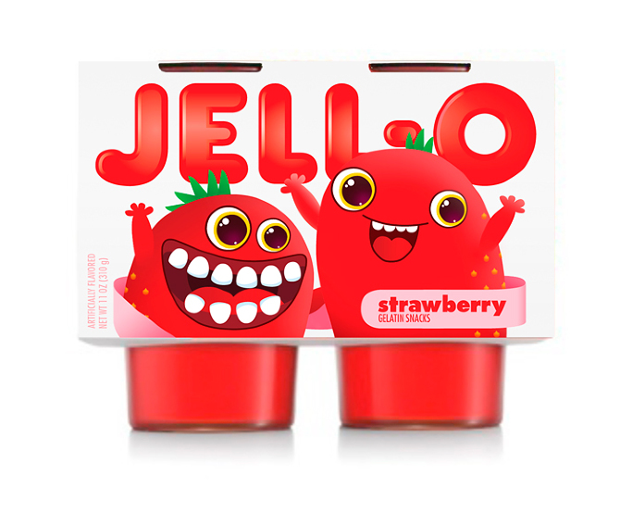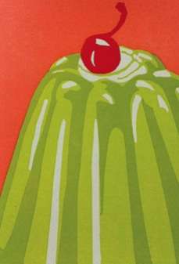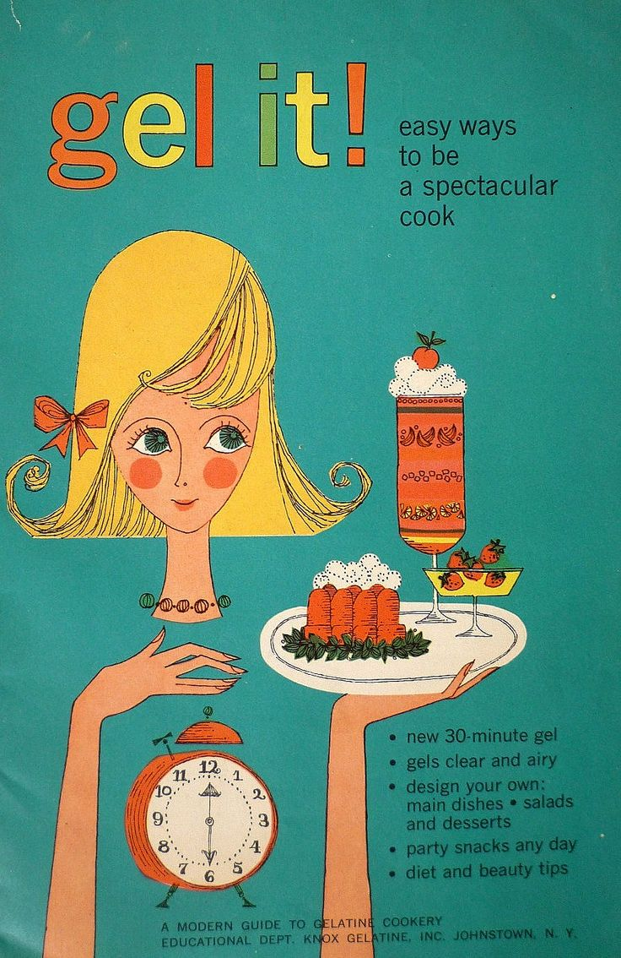­­­v

Alternatively, you could go the nostalgia route with these old vintage ads/ illustrations:

